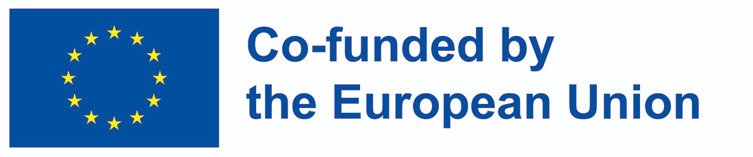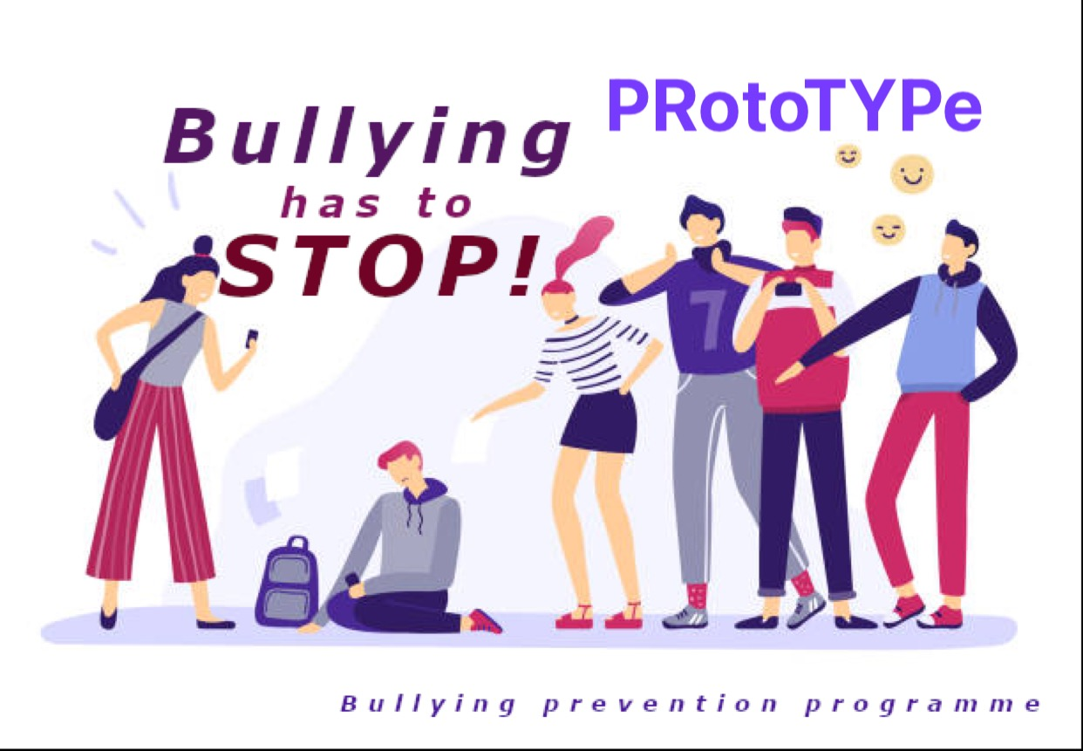

**PRotoTYPe – ​ MINUTES OF THE MEETING**

**The title of the project: : Preventing School-Based Bullying by Creating Early Prevention Programme**

**Project number:** **2021-1-PL01-KA220-SCH-000032708​**

​**Acronym: PRotoTYPe**

**The kick-off meeting**

**Venue:** Wojska Polskiego High School, Chemików 1 Street, Nowy Dwór Mazowiecki, Poland

**Subject: The Kick- off Project Meeting**

**Location:** ​Wojska Polskiego High School

**Date & Time:​** 25.10.22 - 26.10.22

**Hosts:** Marzena Kisiel, Agnieszka Kowalska

**Attendees:**

Oya Simsek Guler- OMEM

Nagihan Gunes - OMEM, Bursa

Filiz Hititsoy, Nihal Görür - Hurriet Anadolu Lisesi, Bursa

Sanna Qvick,​ Olemisen Balanssia ry: Finland

Joao Pedro Carvalho, Slavisa Tomic

Domenico Marzano, Maria Grazia - I.T. Euclide- Caracciolo (Italy)

Frank Hiddink- Open Education Community Foundation (Belgium)

**Meeting Minutes**

**24th May 2022: Warsaw sightseeing tour:**

The kick-off meeting took place from 24.05-26.05.2022

24.05.2022- Warsaw sightseeing tour establishing long term teamwork cooperation.

To enhance project partners' cooperation and make it easier and more profitable,

the first transnational meeting started with the establishment of a strong alliance among the partners and mutual cooperation. The project partners had the chance to get to know each other, exchange their ideas and experience exploring Warsaw’s landmarks such as**:** the Royal Łazienki Park, the Royal Garden, the Palace on the Isle, the Romantic Garden, the Old Orangery, the Amphitheatre and the gondola route across Royal Pond, the New Town area and the Old Town route the New Town- the Warsaw Barbican and the City Walls - the Old Town Market, The Royal Castle area, St. John’s Cathedral, the viewing platform with a stunning panoramic view, a stroll through Krakowskie Przedmieście and Nowy Świat Street BUW Gardens- the Rooftop Garden of the University Library. A visit to the Palace of Culture and Science: a panoramic view and a vantage point.

**DAY 2: 25th May, 2022**

**I. Welcome Session**

The PRotoTYPe Meeting started at 9:30 with a welcome by the hosts and the presentation of the agenda for the project working days. Meeting at school, a warm welcome by the Headmistress of Wojska Polskiego High School and the Polish Erasmus+ team.

**II. A training session on bullying in a school environment, a school- based bullying prevention programme and a bullying prevention plan in practice.**

25.05.2022- a training session on bullying in a school environment conducted by a professional trainer Jacek Staniszewski, the headteacher of the Academy of Good Education. He also presented the core issues of a school- based bullying prevention programme and a bullying prevention plan in practice. A training session- part 2: types of analysis in a bullying research, a situation, factor and need analysis, guidance materials, presentations of the partner organisations and the situation analysis, working on the project tasks and the risk analysis. The participants were familiar with the main project activities and the bullying issues in a school society.

**III. A training session: types of analysis in bullying research, a situation, factor and need analysis, guidance materials.**

The project partners worked on the project analysis and compared various types of the project researches and techniques.

**IV. Presentations of the partner organisations and the situation analysis .**

**Working on the project: project tasks and the risk analysis**

**V. Preparatory tasks before the next transnational meeting**: tasks according to the schedule.

After the lunch break, we discussed the preparatory tasks before the next transnational meeting: tasks according to the deadlines. The project partner - Oya will send the tasks essential to be done before the next meeting in Turkey. The project partners were asked to be familiar with all the project tasks presented in the project form and the project leaflet.

**VI. Evaluation of the project tasks up to now: the participants filled in the evaluation questionnaires prepared by the Belgium Partner.**

The results of the feedback were analysed and presented to the partners.

**VII. Closing the meeting**

The meeting finished at 17:00

**DAY 3: 26th May, 2022**

26.05.2022- working on the project, organisational issues and the management of the project, official documents, multiplier events’ budgets, financial issues, intellectual output budget. The second part of the training session: Risk Management Plan and the GDPR issues, working on the project, preparing for the next transnational meeting and future activities, summary of the kick-off meeting, distributing certificates

**I.Working on the project:** the project partners worked on organisational issues and the management of the project: project deadline, official documents, multiplier events’ budgets, financial issues, intellectual output budget. The Project Management Team with the advisory of the Polish coordinator worked on the project requirements and the other project issues according to the Prototype agenda as follows:

**II.Risk Management Plan and GDPR issues**

**III. The upcoming transnational meetings schedule**

Working on the project: preparing for the next transnational meeting and future activities

**IV. Evaluation and conclusions: Summary of the Kick-off Meeting - distributing certificates**

Conclusions: the project activities should be discussed in our group and during online conferences, the project schedule is rearranged according to the suggestions made by the Polish National Agency as the summary of the project application, all the important data will be presented in our project team, the Management Board will guide the project implementation.

**V. Assessment and certificates distribution**

The certificates were distributed by the Polish team.

*This project has been funded with support from the European Commission. This publication reflects the views only of the author, and the Commission cannot be held responsible for any use which may be made of the information contained therein.*